迁移步骤

1. **系统信息**
2. 服务器列表

|  |  |  |  |
| --- | --- | --- | --- |
| 机器 | IP | OS系统 | 实例规格 |
| Postgres14.8 | 10.28.160.242 | CentOS release 6.10(Final) | 88U755G |

1. **系统环境安装准备**
2. 安装pg14.8
   1. 上传文件



* 1. 解压文件

unzip soft_tar.zip

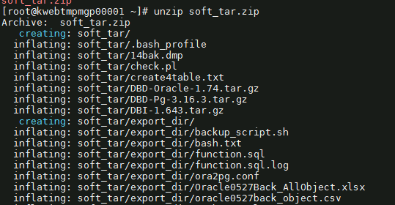

* 1. 禁用SELinux强制模式

sed -i "s/SELINUX=enforcing/SELINUX=disabled/" /etc/selinux/config

setenforce 0

getenforce

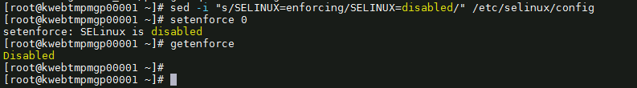

* 1. 关闭防火墙

service iptables stop

* 1. 设置变量

PGDATA=’/data01/pgsql’



* 1. 安装依赖包

yum install -y iproute bind iptables which sudo sysstat ftp make cmake gcc uuid uuid-devel bison flex perl perl-devel python-devel readline readline-devel libxml2 libxml2-devel iotop tcpdump strace gdb systemtap net-tools xdpyinfo libstdc++-devel gcc-c++ ksh libaio libaio-devel libX11 libXau libXi libXtst libXrender libXrender-devel libgcc libstdc++ libstdc++-devel libxcb make smartmontools zlib-devel tcl glibc glibc-devel openssl openssl-devel bc binutils nfs-utils perl-ExtUtils-Embed zstd zstd-devel libcurl libcurl-devel lz4 lz4-devel libicu libicu-devel autoconf

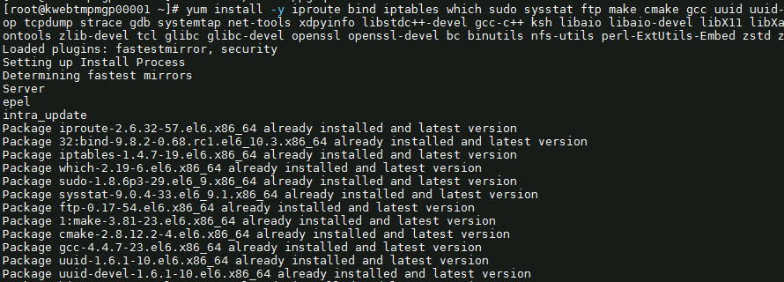

* 1. 创建用户和组

groupadd -g 1000 postgres

useradd -u 1000 -g postgres postgres

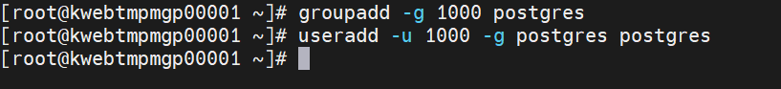

* 1. 创建数据库目录

mkdir -p $PGDATA



* 1. 需要先上传到root

cd soft_tar

tar -zxvf postgresql-14.8.tar.gz -C /data01/app/install 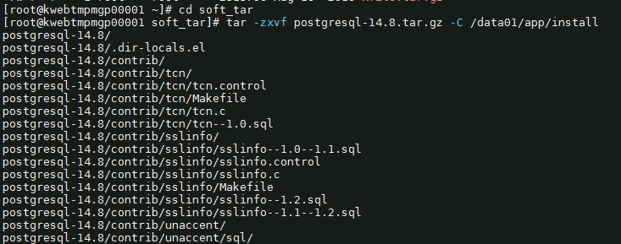

* 1. 修改服务器内存和信号量

echo "kernel.sem = 4096 4194304 32768 1024" >> /etc/sysctl.conf

sysctl -p

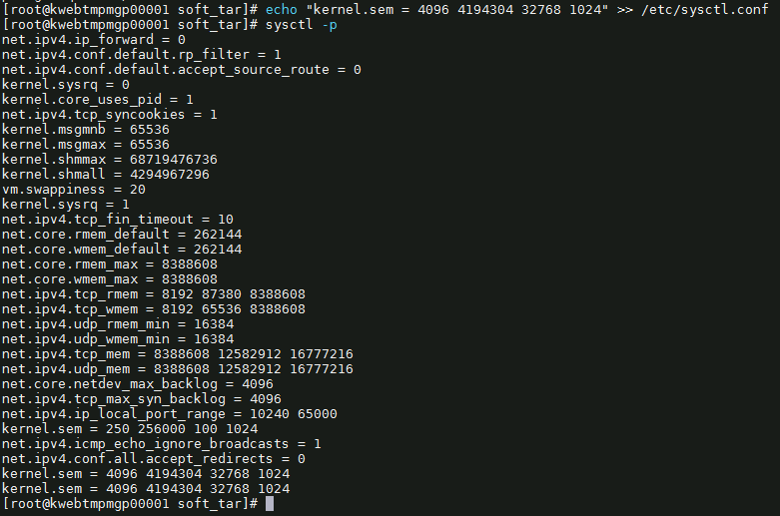

* 1. 修改服务器资源限制

echo "postgres soft nproc unlimited" >> /etc/security/limits.conf

echo "postgres hard nproc unlimited" >> /etc/security/limits.conf

echo "postgres soft nofile 1024000" >> /etc/security/limits.conf

echo "postgres hard nofile 1024000" >> /etc/security/limits.conf

echo "postgres soft stack unlimited" >> /etc/security/limits.conf

echo "postgres hard stack unlimited" >> /etc/security/limits.conf

echo "postgres soft memlock unlimited" >> /etc/security/limits.conf

echo "postgres hard memlock unlimited" >> /etc/security/limits.conf

echo "postgres soft core unlimited" >> /etc/security/limits.conf

echo "postgres hard core unlimited" >> /etc/security/limits.conf

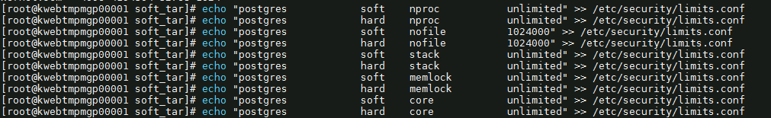

报错没有权限写入

chattr -i /etc/security/limits.conf

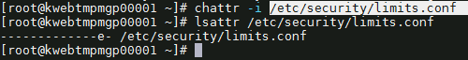

* 1. 编译包

cd /data01/app/install/postgresql-14.8

./configure --prefix=/data01/app/postgresql

make world && make install-world

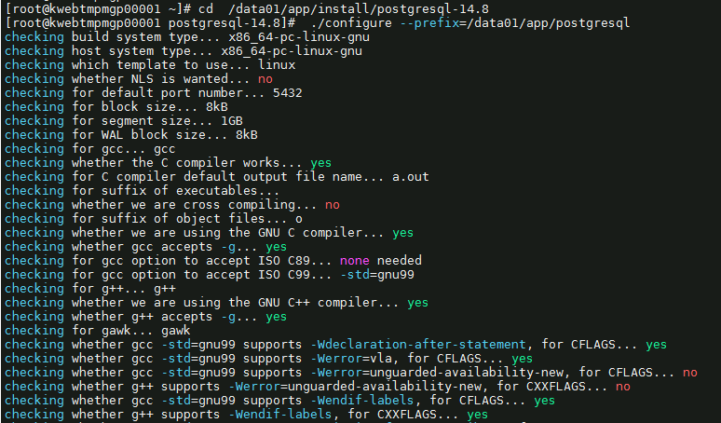

* 1. 添加配置文件

su - postgres -c "echo 'export PG_HOME=/data01/app/postgresql' >> /home/postgres/.bash_profile"

su - postgres -c "echo 'export LD_LIBRARY_PATH=\$PG_HOME/lib' >> /home/postgres/.bash_profile"

su - postgres -c "echo 'export PGDATA=$PGDATA' >> /home/postgres/.bash_profile"

su - postgres -c "echo 'export PATH=\$PG_HOME/bin:\$PATH' >> /home/postgres/.bash_profile"

su - postgres -c "echo 'PATH=\$PATH:\$PG_HOME/.local/bin:\$PG_HOME/bin' >> /home/postgres/.bash_profile"

su - postgres -c "echo 'export PATH' >> /home/postgres/.bash_profile"

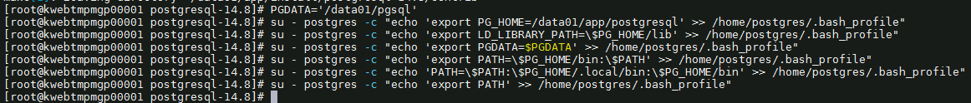

* 1. 初始化数据库

chown -R postgres:postgres /data01/app/install

chown -R postgres:postgres /data01/app/postgresql

chown -R postgres:postgres $PGDATA



su - postgres -c "/data01/app/postgresql/bin/initdb -D $PGDATA -E UTF8"

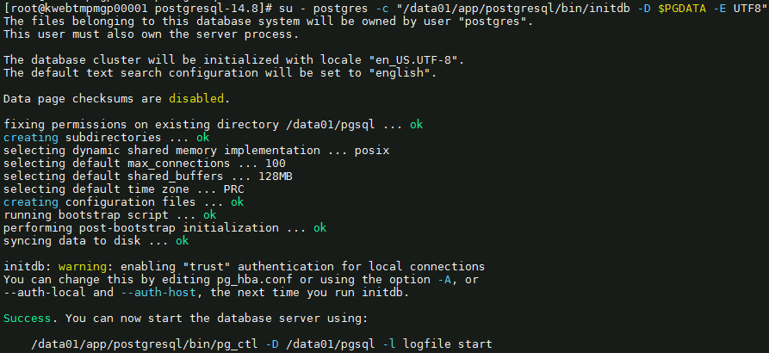

* 1. 创建归档日志目录

su - postgres -c "mkdir -p $PGDATA/archivedir"



* 1. 修改pg_hba.conf

su - postgres -c "echo 'host all all 0/0 md5' >> $PGDATA/pg_hba.conf"

su - postgres -c "echo 'host replication replica 0/0 md5' >> $PGDATA/pg_hba.conf"



* 1. 配置postgresql.conf

if [ $(lscpu |grep '^CPU(s): ' | awk -F " " '{print $1}') == 'CPU(s):' ]

then

CPU=$(lscpu |grep '^CPU(s): ' | awk -F " " '{print $2}')

elif [ $(lscpu |grep '^CPU: ' | awk -F " " '{print $1}') == 'CPU:' ]

then

CPU=$(lscpu |grep '^CPU: ' | awk -F " " '{print $2}')

else

echo "没有符合的条件"

fi

MEM_S=$(free -m|grep '^Mem:' | awk -F " " '{print expr $2/1024*0.4}' | cut -d '.' -f1)GB

MEM_E=$(free -m|grep '^Mem:' | awk -F " " '{print $2/1024*0.5}' | cut -d '.' -f1)GB

sed -i "s/#listen_addresses = 'localhost'/listen_addresses = '*'/" $PGDATA/postgresql.conf

sed -i "s/#port = 5432/port = 5432/" $PGDATA/postgresql.conf

sed -i "s/max_connections = 100/max_connections = 3000/" $PGDATA/postgresql.conf

# 开启大页，这个项也要开启

# sed -i "s/#huge_pages = try/huge_pages = on/" $PGDATA/postgresql.conf

sed -i "s/shared_buffers = 128MB/shared_buffers = $MEM_S/" $PGDATA/postgresql.conf

sed -i "s/#work_mem = 4MB/work_mem = 16MB/" $PGDATA/postgresql.conf

sed -i "s/#wal_buffers = -1/wal_buffers = 16MB/" $PGDATA/postgresql.conf

sed -i "s/#checkpoint_completion_target = 0.9/checkpoint_completion_target = 0.9/" $PGDATA/postgresql.conf

sed -i "s/max_wal_size = 1GB/max_wal_size = 8GB/" $PGDATA/postgresql.conf

sed -i "s/min_wal_size = 80MB/min_wal_size = 2GB/" $PGDATA/postgresql.conf

sed -i "s/#archive_mode = off/archive_mode = on/" $PGDATA/postgresql.conf

sed -i "s/#archive_command = ''/archive_command = 'test ! -f \/data01\/pgsql\/archivedir\/%f \&\& cp %p \/data01\/pgsql\/archivedir\/%f'/" $PGDATA/postgresql.conf

sed -i "s/#default_statistics_target = 100/default_statistics_target = 100/" $PGDATA/postgresql.conf

sed -i "s/#log_destination = 'stderr'/log_destination = 'csvlog'/" $PGDATA/postgresql.conf

sed -i "s/#logging_collector = off/logging_collector = on/" $PGDATA/postgresql.conf

sed -i "s/#effective_cache_size = 4GB/effective_cache_size = $MEM_E/" $PGDATA/postgresql.conf

sed -i "s/#random_page_cost = 4.0/random_page_cost = 1.1/" $PGDATA/postgresql.conf

sed -i "s/#maintenance_io_concurrency = 10/maintenance_io_concurrency = 200/" $PGDATA/postgresql.conf

sed -i "s/#max_worker_processes = 8/max_worker_processes = $CPU/" $PGDATA/postgresql.conf

ccccsed -i "s/#max_parallel_workers_per_gather = 2/max_parallel_workers_per_gather = 4/" $PGDATA/postgresql.conf

sed -i "s/#max_parallel_maintenance_workers = 2/max_parallel_maintenance_workers = 4/" $PGDATA/postgresql.conf

sed -i "s/#max_parallel_workers = 8/max_parallel_workers = $CPU/" $PGDATA/postgresql.conf

sed -i "s/#wal_log_hints = off/wal_log_hints = on/" $PGDATA/postgresql.conf

sed -i "s/#restore_command = ''/restore_command = 'cp \/data01\/pgsql\/archivedir\/%f %p'/" $PGDATA/ postgresql.conf

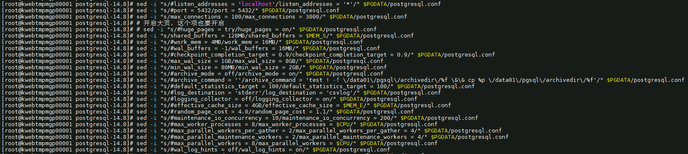

1. 安装ora2pg
   * 1. 安装perl

yum install -y perl perl-ExtUtils-CBuilder perl-ExtUtils-MakeMaker

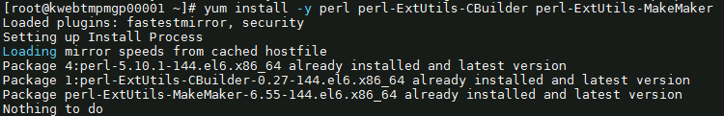

perl -v

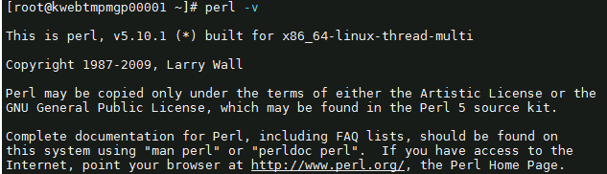

* + 1. 安装oracle客户端

rpm -ivh oracle-instantclient11.2-basic-11.2.0.4.0-1.x86_64.rpm

rpm -ivh oracle-instantclient11.2-devel-11.2.0.4.0-1.x86_64.rpm

rpm -ivh oracle-instantclient11.2-jdbc-11.2.0.4.0-1.x86_64.rpm

rpm -ivh oracle-instantclient11.2-sqlplus-11.2.0.4.0-1.x86_64.rpm

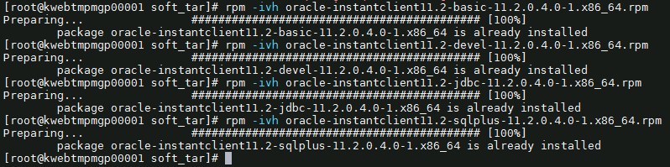

* + 1. 安装DBI模块

tar zxvf DBI-1.643.tar.gz

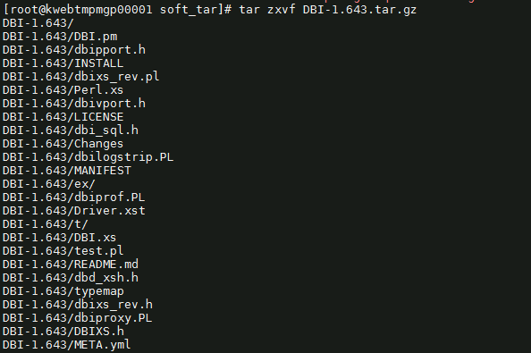

cd DBI-1.643

perl Makefile.PL

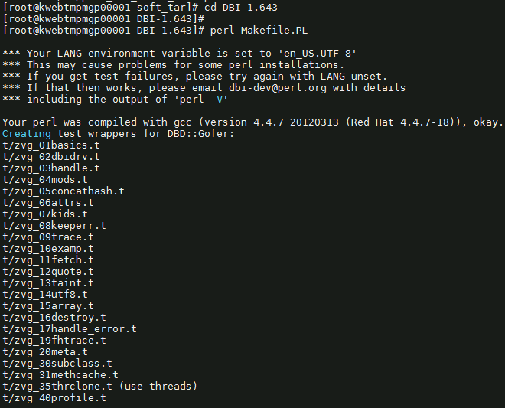

make

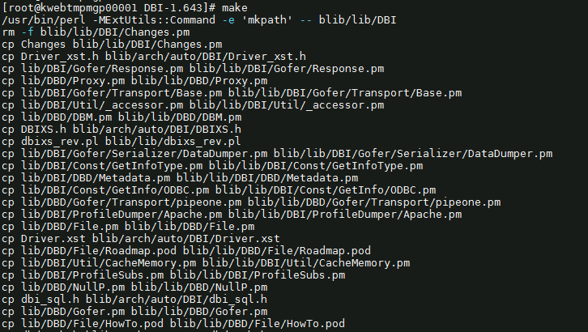

make install

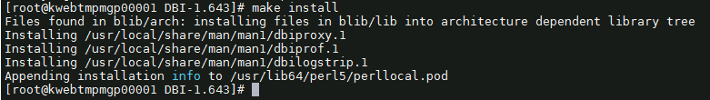

* + 1. 安装DBD::oracle驱动模块

vi /etc/profile

export LD_LIBRARY_PATH=/usr/lib/oracle/11.2/client64/lib

export ORACLE_HOME=/usr/lib/oracle/11.2/client64

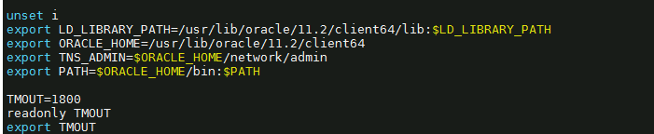

source /etc/profile

tar zxvf DBD-Oracle-1.74.tar.gz

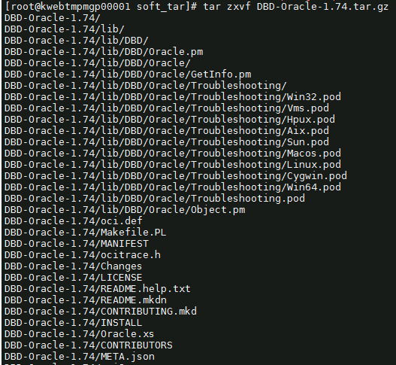

cd DBD-Oracle-1.74

perl Makefile.PL

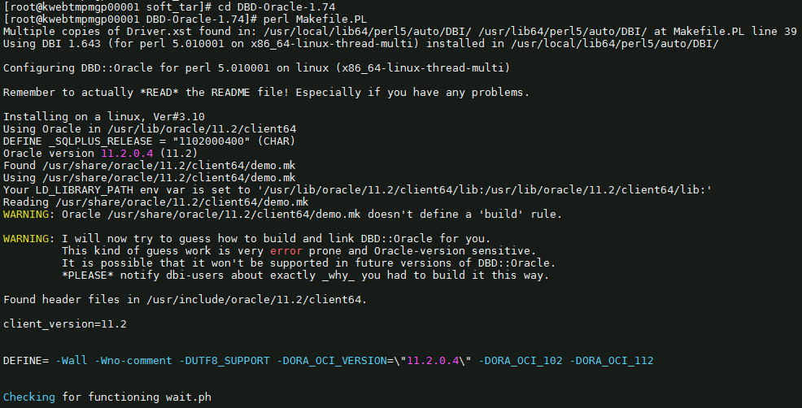

make

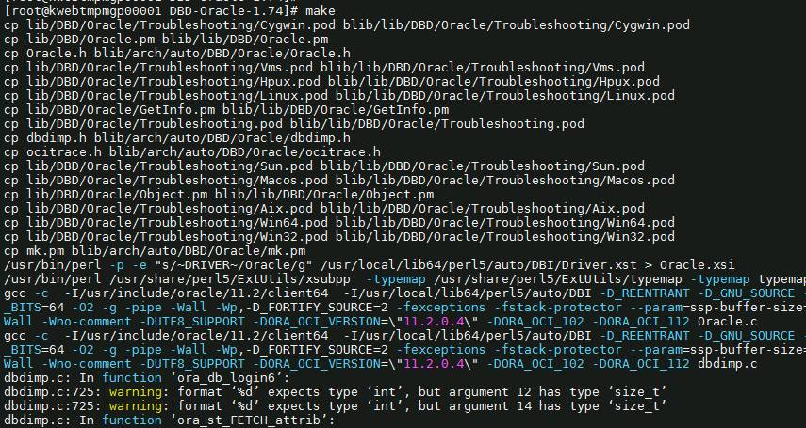

make install

* + 1. 安装DBD:pg驱动模块

Vi /etc/profile

export POSTGRES_INCLUDE="/data01/app/postgresql/include"

export POSTGRES_LIB="/data01/app/postgresql/lib"

export POSTGRES_HOME="/data01/app/postgresql"



source /etc/profile

tar zxvf DBD-Pg-3.16.3.tar.gz

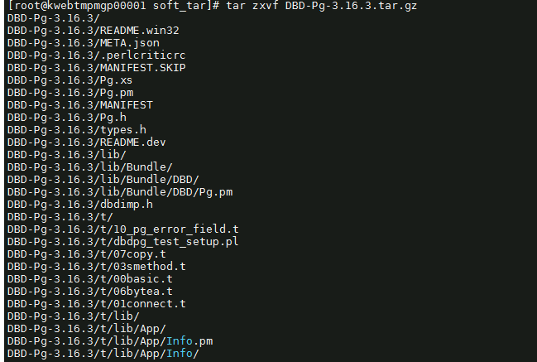

cd DBD-Pg-3.16.3

perl Makefile.PL

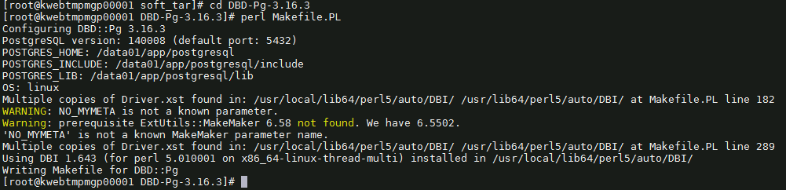

make

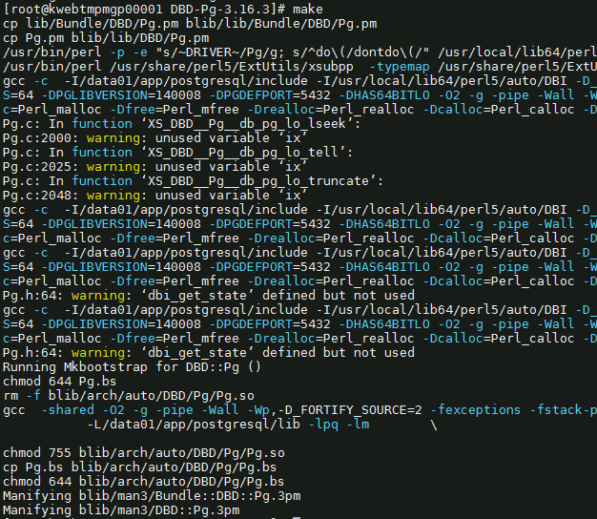

make install



* + 1. 安装ora2pg

tar -xvjf ora2pg-24.0.tar.bz2

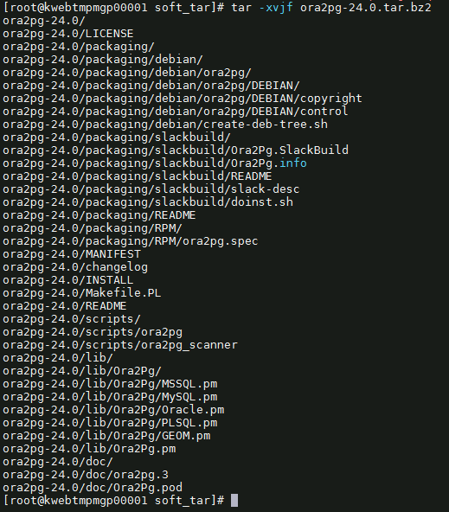

cd ora2pg-24.0

perl Makefile.PL

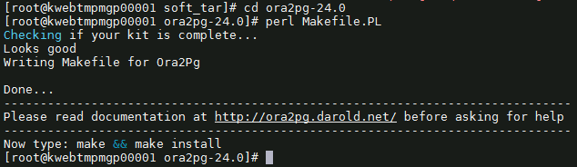

make && make install

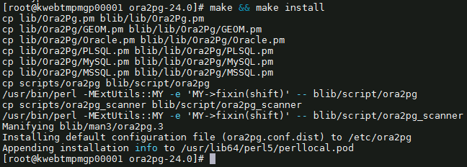

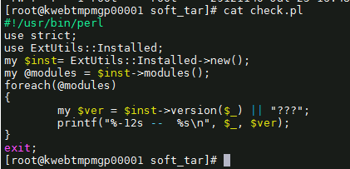

perl check.pl

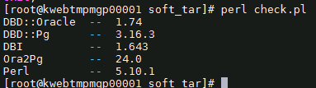

ora2pg



1. 安装oracle_fdw
   1. 下载地址：

https://github.com/laurenz/oracle_fdw

下载到 /home/postgres

* 1. 安装步骤

tar -zxvf oracle_fdw-ORACLE_FDW_2_6_0.tar.gz

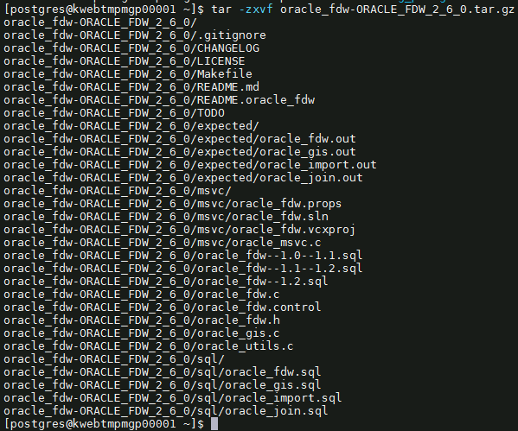

cd oracle_fdw-ORACLE_FDW_2_6_0

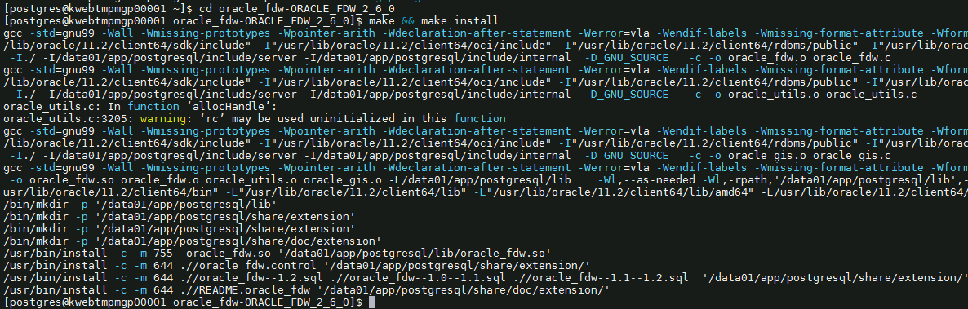

* 1. 添加环境变量

vi .bash_profile

PATH=$PATH:$HOME/bin

export PATH

export PG_HOME=/data01/app/postgresql

export ORACLE_HOME=/usr/lib/oracle/11.2/client64

export LD_LIBRARY_PATH=$PG_HOME/lib

export PGDATA=/data01/pgsql

export PATH=$PG_HOME/bin:$ORACLE_HOME/bin:$PATH

PATH=$PATH:$PG_HOME/.local/bin:$PG_HOME/bin

export LD_LIBRARY_PATH=/usr/lib/oracle/11.2/client64/lib:$LD_LIBRARY_PATH

export TNS_ADMIN=$ORACLE_HOME/network/admin

export PATH

export PG_HOME=/data01/app/postgresql

export LD_LIBRARY_PATH=$PG_HOME/lib

export PGDATA=/data01/pgsql

export PATH=$PG_HOME/bin:$PATH

PATH=$PATH:$PG_HOME/.local/bin:$PG_HOME/bin

export PATH

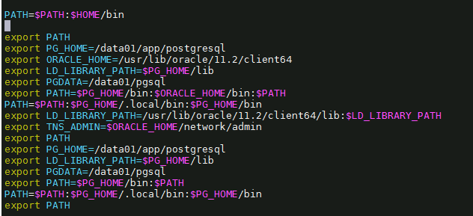

* 1. 修改/etc/ld.so.conf添加一行

/usr/lib/oracle/11.2/client64/lib

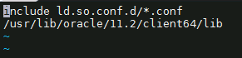

运行ldconfig



* 1. 数据库加载插件



* 1. 新建tnsnames.ora

cd /usr/lib/oracle/11.2/client64/network/admin

vi tnsnames.ora

test_oracle =

(DESCRIPTION =

(ADDRESS_LIST=

(ADDRESS=(PROTOCOL=TCP)(HOST=MPMUAToracle01.beta.hic.cloud)(PORT=1521))

)

(CONNECT_DATA=

(SERVICE_NAME=MPMUAT_srv)

)

)

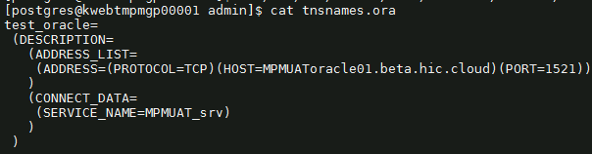

* 1. 修改/etc/hosts文件

127.0.0.1 kwebtmpmgp0001.novalocal

cat /etc/hosts

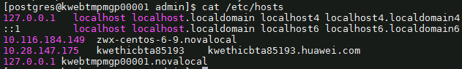

1. **数据库准备**
2. 查看原数据库信息
   1. 查原库oracle对象

select object_type,count(*) from dba_objects where owner='INFODBA' group by object_type;

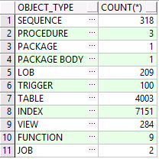

* 1. 查看原库每张表的大小和记录

select table_name,round((num_rows * avg_row_len) / 1024 /1024,2) AS table_size_mb,num_rows from all_tables where owner = 'INFODBA' and num_rows is not null order by 2 desc;

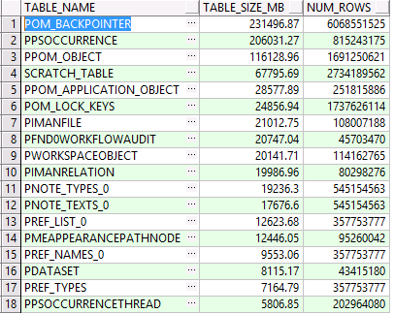

1. 数据库准备

2.1.新建用户

CREATE USER infodba SUPERUSER PASSWORD 'infodba';

CREATE USER replica PASSWORD '123456' REPLICATION;

CREATE USER pgrewind SUPERUSER PASSWORD '123456';

create user TcClusterDB password 'tcclusterdb';

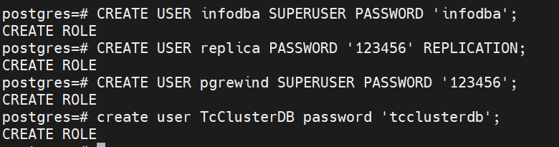

2.2新建表空间

-- infodba_idata /data01/pgsql/tc/infodba_idata

-- infodba_ilog /data01/pgsql/tc/infodba_ilog

-- infodba_indx /data01/pgsql/tc/infodba_index

--tcclusterdb_idata /data01/pgsql/tc/tcclusterdb_idata

mkdir -p /data01/pgsql/tc/infodba_idata

mkdir -p /data01/pgsql/tc/infodba_ilog

mkdir -p /data01/pgsql/tc/infodba_index

mkdir -p /data01/pgsql/tc/tcclusterdb_idata



CREATE TABLESPACE infodba_idata LOCATION '/data01/pgsql/tc/infodba_idata';

CREATE TABLESPACE infodba_ilog LOCATION '/data01/pgsql/tc/infodba_ilog';

CREATE TABLESPACE infodba_indx LOCATION '/data01/pgsql/tc/infodba_index';

CREATE TABLESPACE tcclusterdb_idata LOCATION '/data01/pgsql/tc/tcclusterdb_idata';

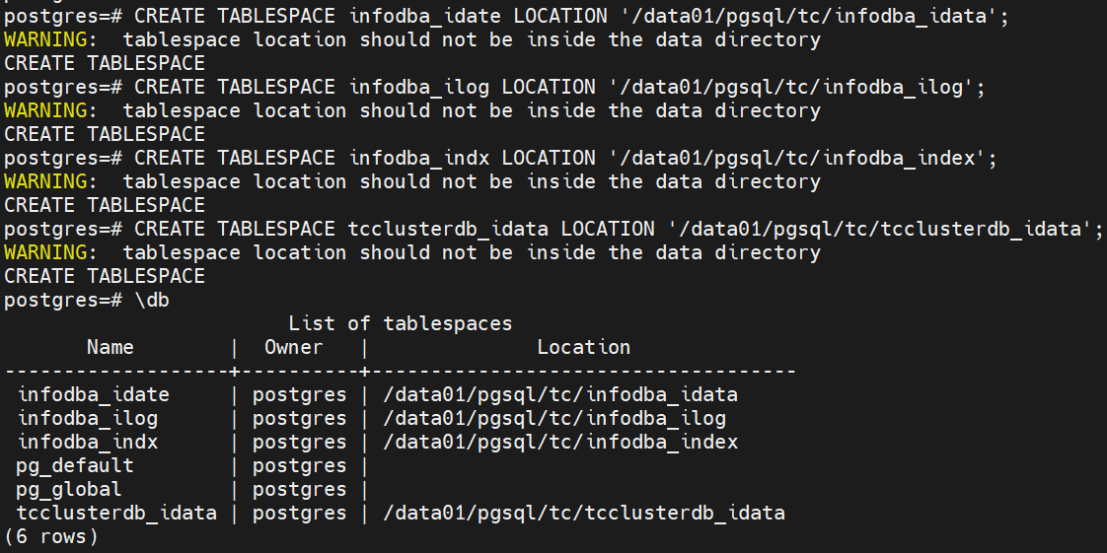

2.3新建库

CREATE DATABASE tc WITH owner infodba encoding 'UTF8' template template0 LC_COLLATE='C' tablespace infodba_idata ;

create database TcClusterDB with owner TcClusterDB encoding 'UTF8' template template0 lc_collate 'C' tablespace TcClusterDB_idata;

grant all privileges on database TcClusterDB to TcClusterDB;

grant CREATE ON TABLESPACE TcClusterDB_idata to TcClusterDB;

grant all privileges on database tc to infodba;

grant CREATE ON TABLESPACE infodba_idata to infodba;

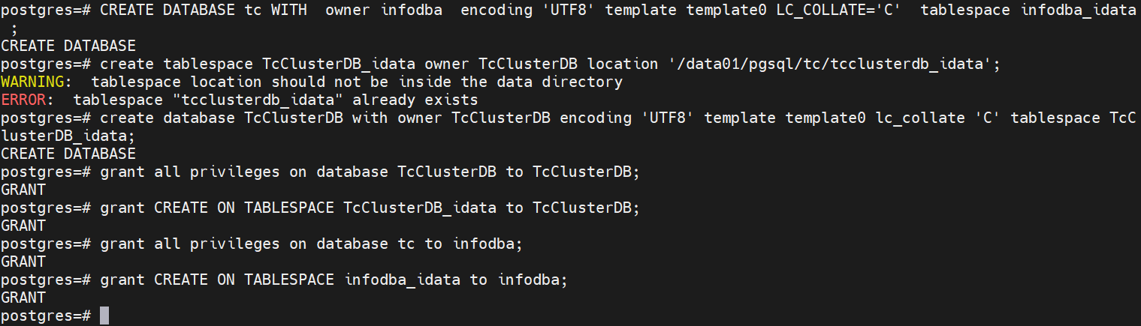

2.4修改认证md5

vi postgres.conf

password_encryption = md5;



重设密码

Alter user infodba password ‘infodba’;



1. **迁移为了方便创建的函数**
2. 新建函数及表
   1. 新建传输任务
3. 删除函数及表
4. **Oracle数据库表、索引迁移到PG库**
5. 使用flashsync导表结构
   1. 选择引擎

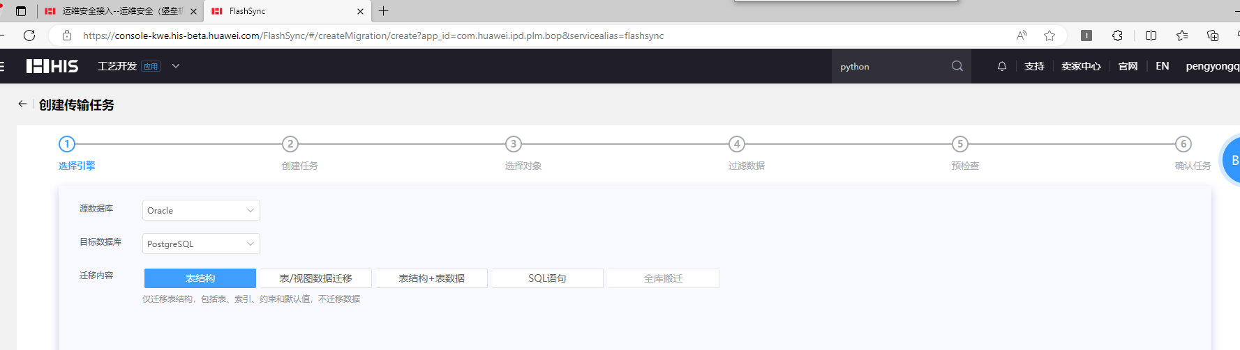

* 1. 创建任务

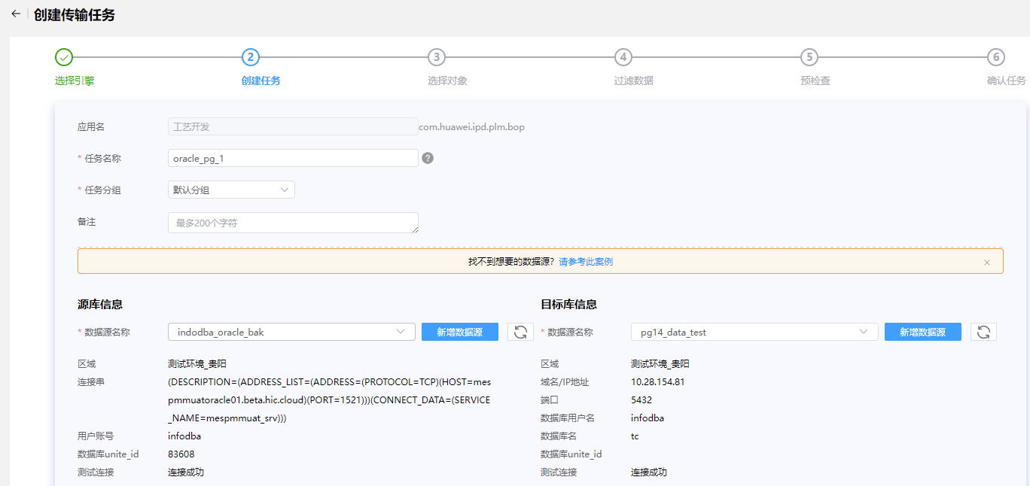

* 1. 选择对象

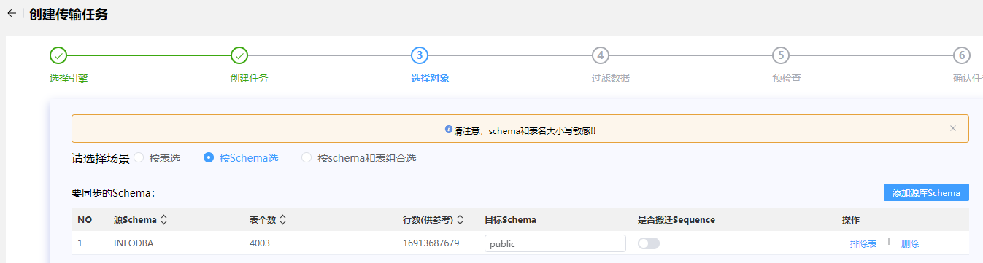

排除表mmv_spatial_cell_index

* 1. 过滤数据

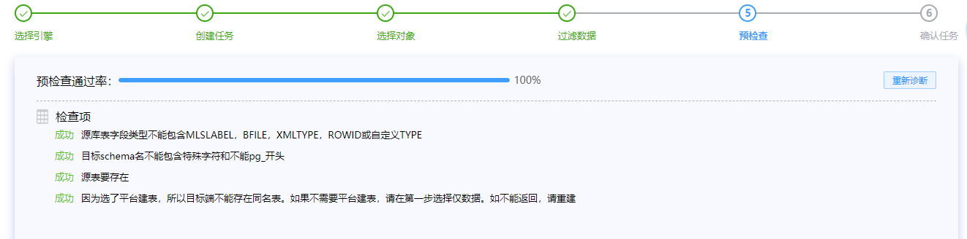

* 1. 预检查

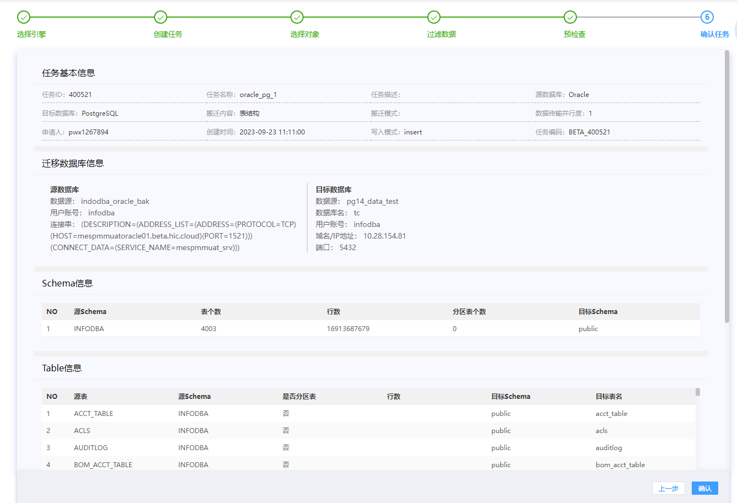

* 1. 确认任务

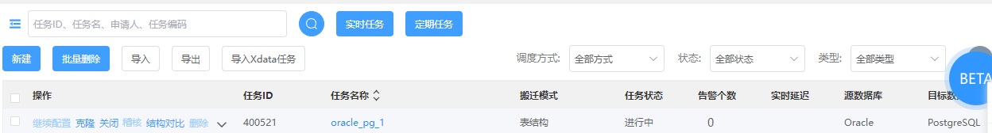

1. flashsync导表数据
   1. 选择引擎

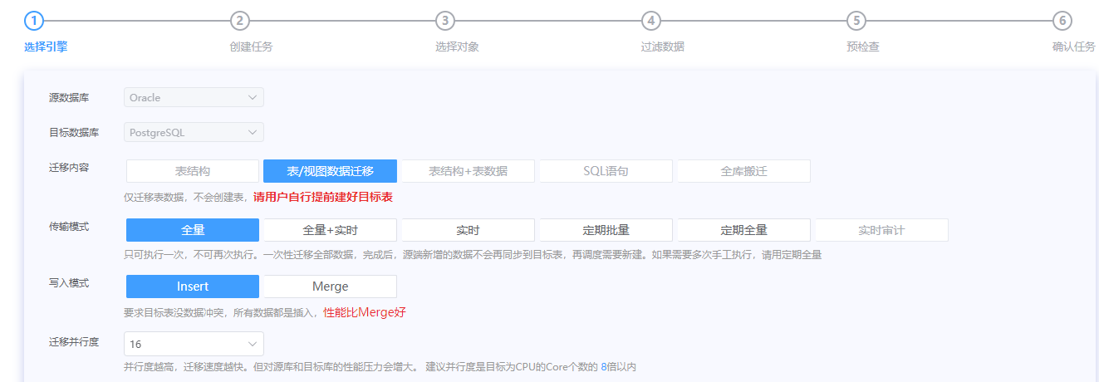

16迁移并发度

* 1. 创建任务

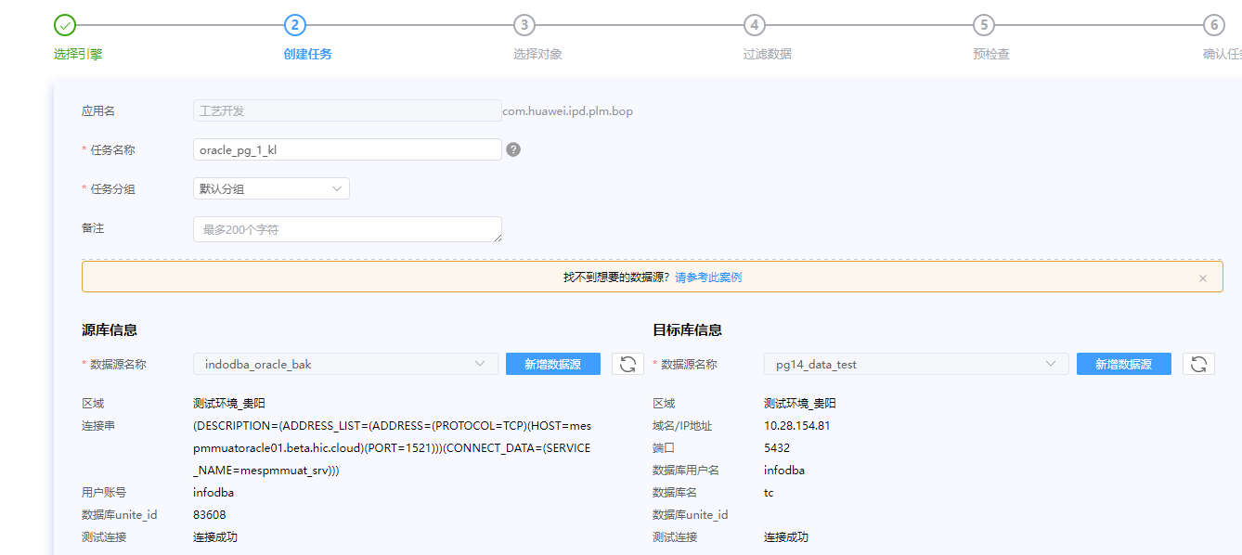

* 1. 选择对象

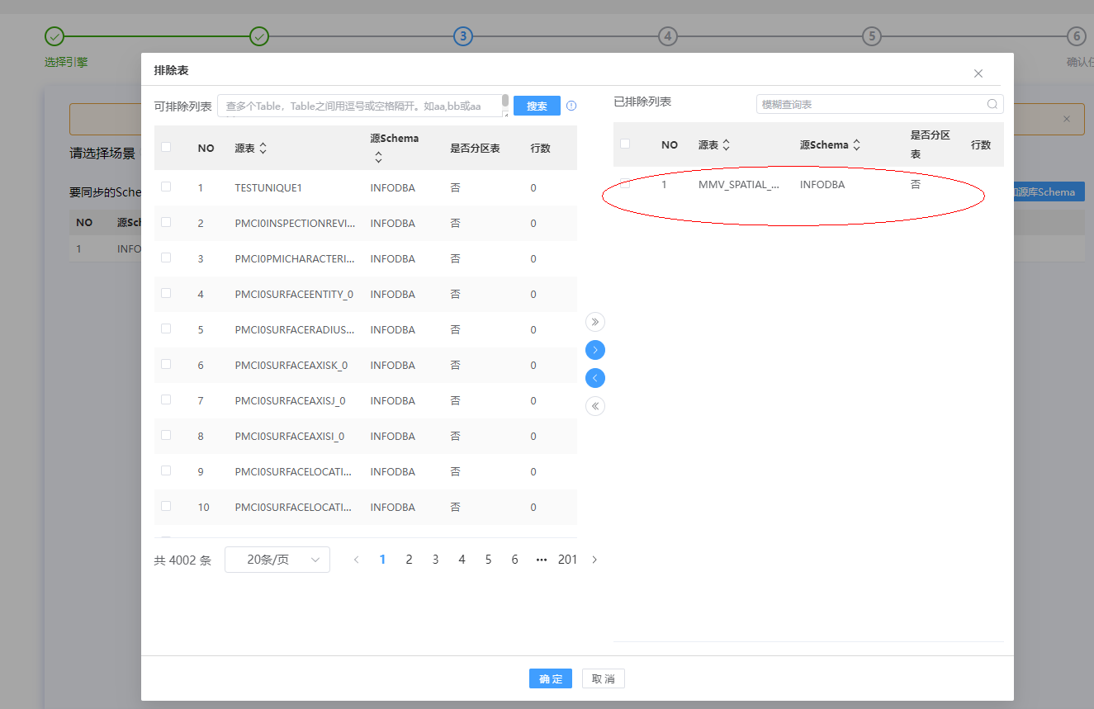

排除表mmv_spatial_cell_index

* 1. 过滤数据

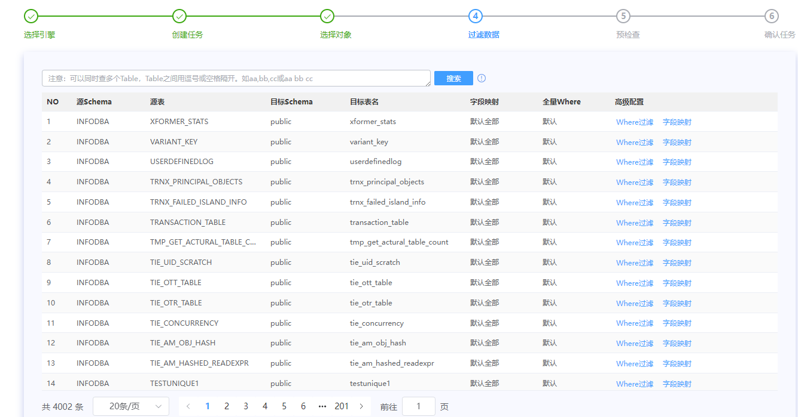

* 1. 预检查

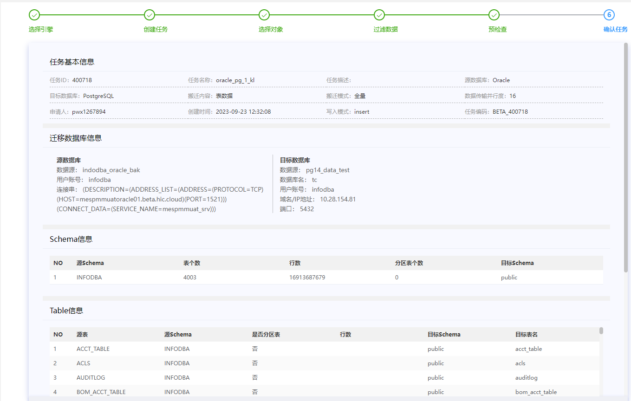

* 1. 确认任务



* 1. 创建mmv_spatial_cell_index （ora2pg -c ora2pg.conf -a mmv_spatial_cell_index -o mmv.sql）

CREATE TABLE mmv_spatial_cell_index (

puid varchar(15) NOT NULL,

spatial_rep varchar(15) NOT NULL,

cell_id numeric(38) NOT NULL,

occ_path_prefix varchar(900) NOT NULL,

occ_path_suffix varchar(4000),

pxmin bigint NOT NULL,

ymin bigint NOT NULL,

zmin bigint NOT NULL,

pxmax bigint NOT NULL,

ymax bigint NOT NULL,

zmax bigint NOT NULL

) ;

CREATE UNIQUE INDEX mmvspatialcellindex_puid_pk ON mmv_spatial_cell_index (puid);

CREATE INDEX mmv_spatial_cellid1 ON mmv_spatial_cell_index (cell_id);

CREATE INDEX mmv_spatial_occpathprefix1 ON mmv_spatial_cell_index (occ_path_prefix);

CREATE INDEX mmv_spatial_spatialrep1 ON mmv_spatial_cell_index (spatial_rep);

ALTER TABLE mmv_spatial_cell_index ALTER COLUMN PUID SET NOT NULL;

ALTER TABLE mmv_spatial_cell_index ALTER COLUMN SPATIAL_REP SET NOT NULL;

ALTER TABLE mmv_spatial_cell_index ALTER COLUMN CELL_ID SET NOT NULL;

ALTER TABLE mmv_spatial_cell_index ALTER COLUMN OCC_PATH_PREFIX SET NOT NULL;

ALTER TABLE mmv_spatial_cell_index ALTER COLUMN pXMIN SET NOT NULL;

ALTER TABLE mmv_spatial_cell_index ALTER COLUMN YMIN SET NOT NULL;

ALTER TABLE mmv_spatial_cell_index ALTER COLUMN ZMIN SET NOT NULL;

ALTER TABLE mmv_spatial_cell_index ALTER COLUMN pXMAX SET NOT NULL;

ALTER TABLE mmv_spatial_cell_index ALTER COLUMN YMAX SET NOT NULL;

ALTER TABLE mmv_spatial_cell_index ALTER COLUMN ZMAX SET NOT NULL;

再使用工具flashsync把数据导入。

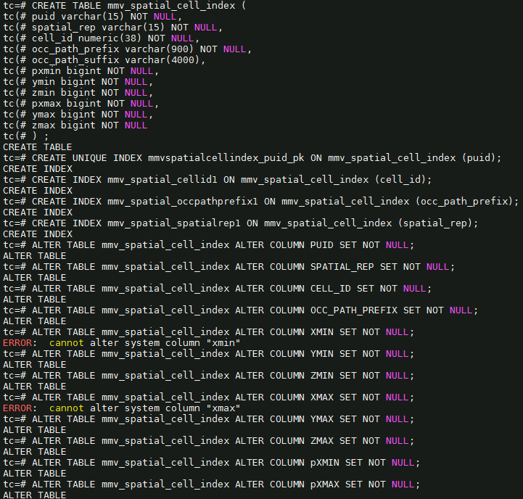

* 1. 索引报错处理

rebuild index piph6specialoperationreq_0 error,error:index row size 2808 exceeds btree version 4 maximum 2704 for index "piph6specialoperationreq_0" DETAIL: Index row references tuple (8386,36) in relation "ph6specialoperationreq". HINT: Values larger than 1/3 of a buffer page cannot be indexed. Consider a function index of an MD5 hash of the value, or use full text indexing.

解决方案：

create extension pg_trgm;

create index ph6specialoperationreq_0 on ph6specialoperationreq using gin (PVAL_0 gin_trgm_ops);

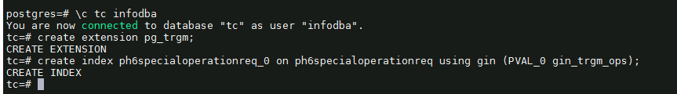

安装插件create extension pg_trgm;报错信息是extenction文件目录中缺少control文件。应该是编译信息没有遍全

( tar -zxvf postgresql-14.8.tar.gz -C /app/install

cd /app/install/postgresql-14.8

./configure –prefix=/app/postgresql

make world && make install-world)

再然后在flashsync,目标表索引重建详情 选择状态 “已失败”，点击“重试”

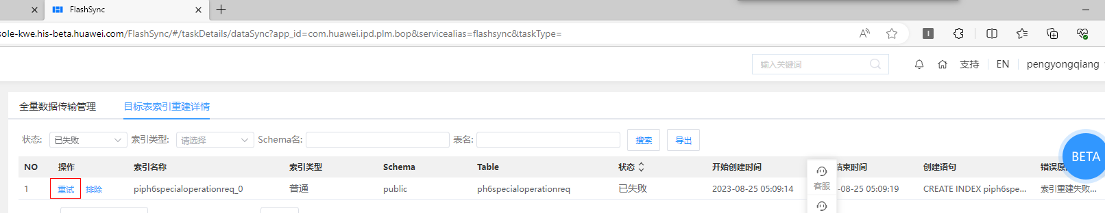

1. **oracle数据库迁移约束、序列、视图、过程、函数、包到PG**
2. 表

call comp.op_user_tables();

select * from tmp1;

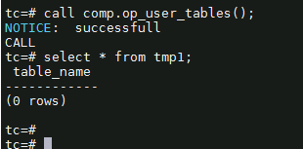

Oracle:

select count(*) from user_tables;

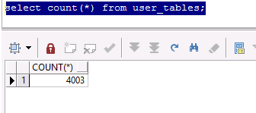

Pg14:

SELECT COUNT(*) AS table_count

FROM information_schema.tables

WHERE table_schema = 'public' and table_type = 'BASE TABLE ';

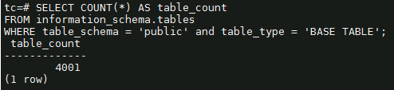

1. 索引

call comp.op_user_indexes();

select * from comp.tmp1;

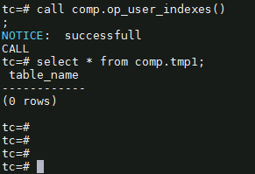

oracle:

select index_name as indexname from user_indexes i where i.index_name not like 'SYS_%';

pg:

select upper(indexname) from pg_indexes where schemaname = 'public' and indexname not like 'sys_%';

1. 约束

vi /data01/soft_tar/export_dir/ora2pg.conf

--修改内容如下

TYPE TABLE

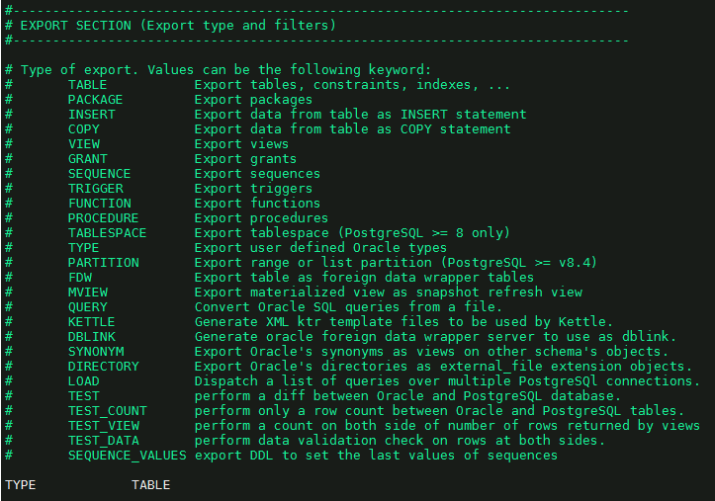

ora2pg -c /data01/soft_tar/export_dir/ora2pg.conf -o /data01/soft_tar/export_dir/test1/output.sql > /data01/soft_tar/export_dir/test1/output.sql.log



查看有没有报错：grep 'psql' output.sql.log

产生的 output.sql 文件用 table_split.pl 处理下，将table的创建语句和constraint，index的创建语句分开。

table_split.pl 内容如下

---------------------------------------------------------------------------------------

open(INPUT, "output.sql");

open(OUTPUT, ">", "table.sql");

open(OUTPUT2, ">", "constraints.sql");

open(OUTPUT3, ">", "index.sql");

while(<INPUT>){

$str.=$_

}

@index=$str=~/CREATE\s*(?:UNIQUE)?\s*INDEX\s+\w+\s+ON[^\n]*;\n/igm;

@constraint=$str=~/ALTER\s*TABLE[^\n]*;\n/igm;

$str=~s/CREATE\s*(?:UNIQUE)?\s*INDEX\s+\w+\s+ON[^\n]*;\n//igm;

$str=~s/ALTER\s*TABLE[^\n]*;\n//igm;

print OUTPUT3 @index;

print OUTPUT2 @constraint;

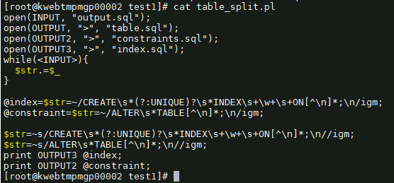

运行 perl table_split.pl

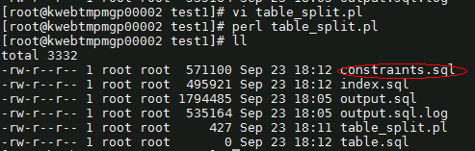

导入约束

psql -U infodba -d tc -f constraints.sql > constraints_output.log 2>&1

grep ‘psql’ constraints_output.log

psql:constraints.sql:53:ERROR:cannot alter system column “xmin”

psql:constraints.sql:56:ERROR:cannot alter system column “xmin”

psql:constraints.sql:7127:ERROR: multiple primary keys for table “pom_lock_keys”

(alter table pom_lock_keys add primary key(puid); ) –主键创造多次，可以忽略。

alter table mmv_spatial_cell_index alter column pxmin set not null;

alter table mmv_spatial_cell_index alter column pxmax set not null;

1. 序列

vi /data01/soft_tar/export_dir/ora2pg.conf

--修改内容如下

TYPE SEQUENCE

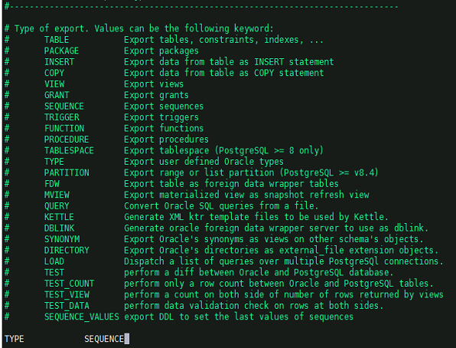

ora2pg -c /data01/soft_tar/export_dir/ora2pg.conf -o /data01/soft_tar/export_dir/test1/sequence.sql > /data01/soft_tar/export_dir/test1/sequence.sql.log

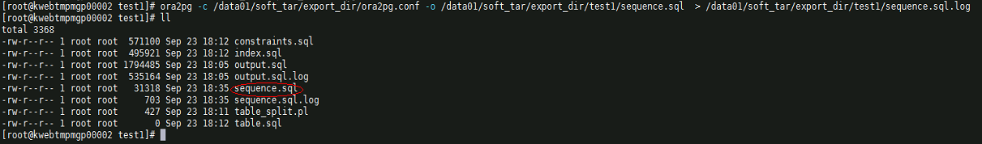

vi sequence.sql

把创建和设置schema删除。因为序列创建到public

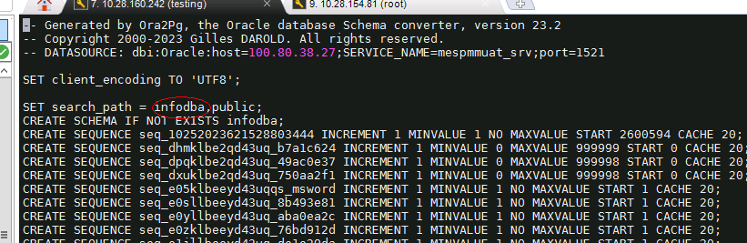

psql -U infodba -d tc -f sequence.sql > sequence_output.log 2>&1

检查：grep 'psql' sequence_output.log

查看oracle序列个数：select count(*) from user_sequences; 318

查看PG序列个数：select count(*) from information_schema.sequences where sequence_schema =CURRENT_SCHEMA; 318

检查哪些没有序列导入

call comp.op_user_seq();

select * from comp.tmp1;

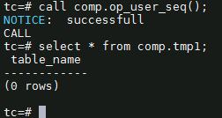

1. 视图

vi /data01/soft_tar/export_dir/ora2pg.conf

--修改内容如下

TYPE VIEW

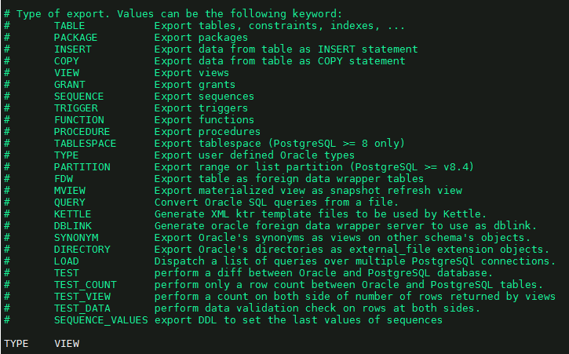

ora2pg -c /data01/soft_tar/export_dir/ora2pg.conf -o /data01/soft_tar/export_dir/test1/view.sql > /data01/soft_tar/export_dir/test1/view.sql.log

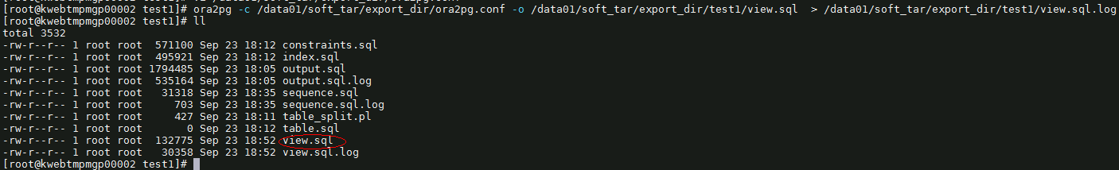

导入

psql -U infodba -d tc -f view.sql > view_output.log 2>&1

grep “psql” view_output.log

psql:view.sql:744: ERROR: function lpad(bigint,integer,unknown) does not exist

psql:view.sql:892: ERROR: function lpad(bigint,integer,unknown) does not exist

psql:view.sql:1116: ERROR: function lpad(bigint,integer,unknown) does not exist

解决方案：

CREATE OR REPLACE FUNCTION pg_catalog.lpad(bigint, integer, varchar)

RETURNS text

LANGUAGE sql

IMMUTABLE STRICT

AS $function$

SELECT pg_catalog.lpad($1::text, $2, $3::text)

$function$

查看oracle视图数量：select count(*) from user_views; 284

查看pg视图数量：select count(*) from information_schema.views where table_schema = CURRENT_SCHEMA; 281

----有相差3个对比一下

Oracle：select view_name as table_name from user_views;

把它导入pg，表名为t1

Pg: select upper(table_name) from information_schema.views where table_schema ='public';

Select * from t1

Except

select upper(table_name) from information_schema.views where table_schema ='public';

结果为

VL10N_EINFO

VL10N_VALUE

VL10N_AWP0CONTENTNAMS

CREATE

OR REPLACE VIEW VL10N_EINFO AS SELECT

puid,

SUBSTR( pval_0, 1, 5 ) AS locale,

SUBSTR( pval_0, 7, 1 ) AS preference,

SUBSTR( pval_0, 9, 1 ) AS status,

SUBSTR( pval_0, 11, 4 ) AS sequence_no,

SUBSTR( pval_0, 49, 240 ) AS pval_0

FROM

PL10N_EINFO UNION ALL

SELECT

PEINFO.puid,

'NONE' AS locale,

'M' AS preference,

'M' AS status,

lpad( pseq, 4, '0' ) AS sequence_no,

pval_0

FROM

PEINFO,

PICML

WHERE

PICML.puid = PEINFO.puid

AND PICML.VLA_487_5 = 0;

CREATE

OR REPLACE VIEW VL10N_VALUE AS SELECT

puid,

SUBSTR( pval_0, 1, 5 ) AS locale,

SUBSTR( pval_0, 7, 1 ) AS preference,

SUBSTR( pval_0, 9, 1 ) AS status,

SUBSTR( pval_0, 11, 4 ) AS sequence_no,

SUBSTR( pval_0, 49, 256 ) AS pval_0

FROM

PL10N_VALUE UNION ALL

SELECT

PVALUE.puid,

'NONE' AS locale,

'M' AS preference,

'M' AS status,

lpad( pseq, 4, '0' ) AS sequence_no,

pval_0

FROM

PVALUE,

PSTXT

WHERE

PSTXT.puid = PVALUE.puid

AND PSTXT.VLA_491_19 = 0;

CREATE

OR REPLACE VIEW VL10N_AWP0CONTENTNAMES AS SELECT

puid,

SUBSTR( pval_0, 1, 5 ) AS locale,

SUBSTR( pval_0, 7, 1 ) AS preference,

SUBSTR( pval_0, 9, 1 ) AS status,

SUBSTR( pval_0, 11, 4 ) AS sequence_no,

SUBSTR( pval_0, 49, 128 ) AS pval_0

FROM

PL10N_AWP0CONTENTNAMES UNION ALL

SELECT

PAWP0CONTENTNAMES.puid,

'NONE' AS locale,

'M' AS preference,

'M' AS status,

lpad( pseq, 4, '0' ) AS sequence_no,

pval_0

FROM

PAWP0CONTENTNAMES,

PAWP0TILETEMPLATE

WHERE

PAWP0TILETEMPLATE.puid = PAWP0CONTENTNAMES.puid

AND PAWP0TILETEMPLATE.VLA_1310_9 = 0;

检查是否全部导入

call comp.op_user_views();

select * from tmp1;

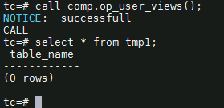

Oracle:

Select count(*) from user_views;

Pg14:

SELECT table_name

FROM information_schema.views

WHERE table_schema = current_schema;

1. 过程

vi ora2pg.conf

--修改内容如下

TYPE PROCEDURE

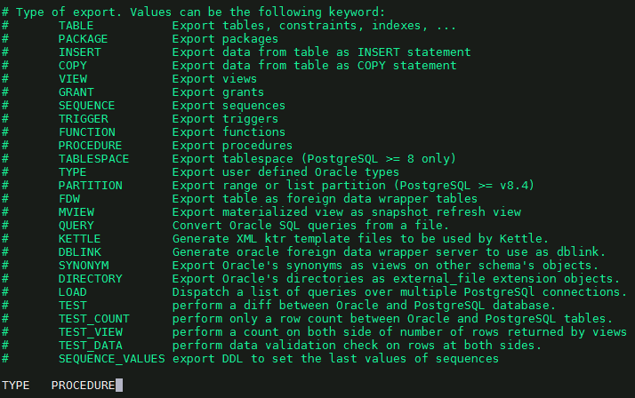

ora2pg -c /data01/soft_tar/export_dir/ora2pg.conf -o /data01/soft_tar/export_dir/test1/procedure.sql > /data01/soft_tar/export_dir/test1/procedure.sql.log

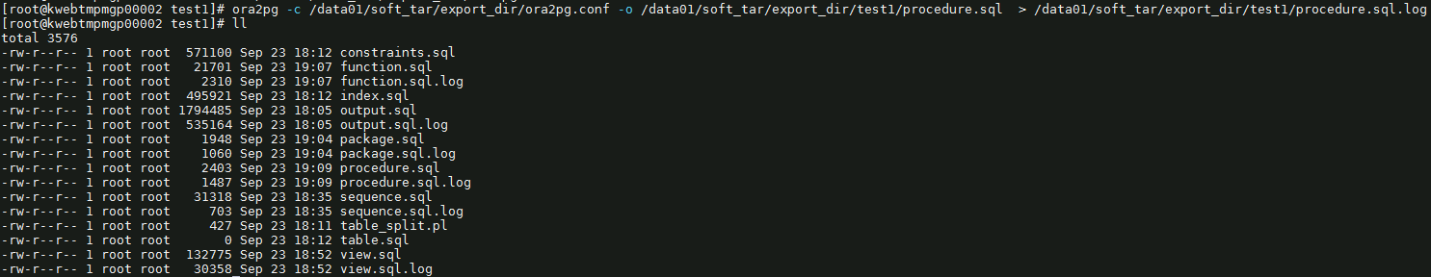

导入

psql -U infodba -d tc -f procedure.sql > procedure_output.log 2>&1

grep ‘psql’ procedure_output.log

psql:procedure.sql:59:ERROR: syntax error at or near “dbms_stats”

1. 函数

Vi ora2pg.conf

--修改内容如下

TYPE FUNCTION

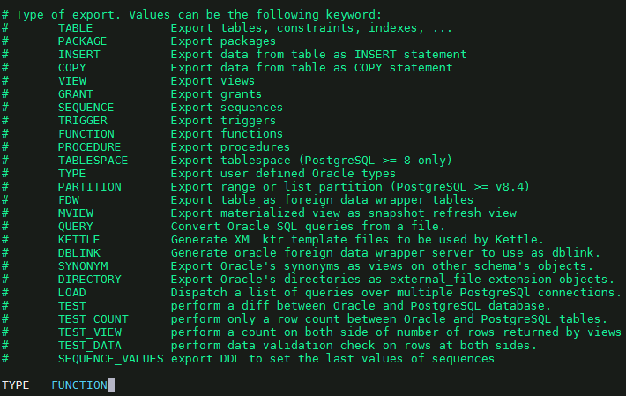

ora2pg -c /data01/soft_tar/export_dir/ora2pg.conf -o /data01/soft_tar/export_dir/test1/function.sql > /data01/soft_tar/export_dir/test1/function.sql.log

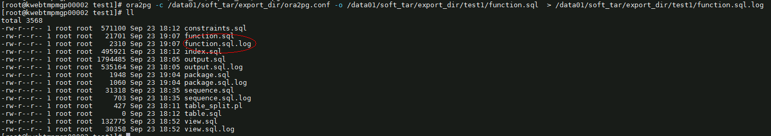

导入（注意把schema删除）

psql -U infodba -d tc -f function.sql > function_output.log 2>&1

grep ‘psql’ function_output.log

psql:function.sql:81:ERROR:syntax error at or near “is” ---此函数初始化里有，直接复制初始化库的。

1. 包

Vi ora2pg.conf

--修改内容如下

TYPE PACKAGE

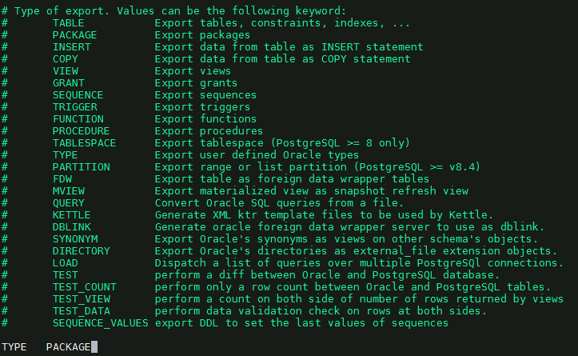

ora2pg -c /data01/soft_tar/export_dir/ora2pg.conf -o /data01/soft_tar/export_dir/test1/package.sql > /data01/soft_tar/export_dir/test1/package.sql.log

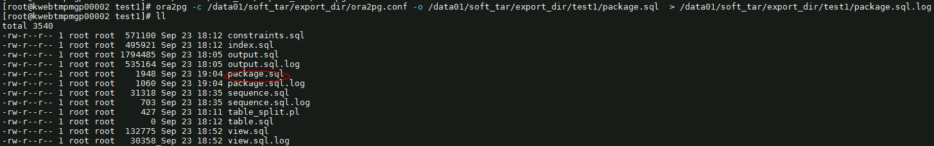

导入

psql -U infodba -d tc -f package.sql > package_output.log 2>&1

1. 数据量的检查

1）在oracle数据库中执行：

-------------------------------------------------------------------------------

create table TMP_GET_ACTURAL_TABLE_COUNT(table_name varchar(50),table_cnt int);

select * from TMP_GET_ACTURAL_TABLE_COUNT;

CREATE OR REPLACE PROCEDURE GET_ACTURAL_TABLE_COUNT(isrun integer) AUTHID CURRENT_USER IS

cursor_sql SYS_REFCURSOR;

record_count number;

BEGIN

FOR cursor_sql IN (SELECT table_name FROM user_tables ) LOOP

EXECUTE IMMEDIATE 'SELECT COUNT(*) FROM ' || cursor_sql.table_name INTO record_count;

INSERT INTO TMP_GET_ACTURAL_TABLE_COUNT (table_name, table_cnt) VALUES (cursor_sql.table_name, record_count);

COMMIT;

END LOOP;

COMMIT;

END;

/

truncate table TMP_GET_ACTURAL_TABLE_COUNT;

call GET_ACTURAL_TABLE_COUNT(1);

commit;

-------------------------------------------------------------------------------

2）在postgresql数据库中执行。

-------------------------------------------------------------------------------

create table TMP_GET_ACTURAL_TABLE_COUNT(table_name varchar(50),table_cnt bigint);

CREATE OR REPLACE PROCEDURE GET_ACTURAL_TABLE_COUNT(isrun integer)

language plpgsql

AS $$

declare

table_count bigint;

cursor_sql record;

begin

for cursor_sql in(

select table_name from information_schema.tables where table_schema='public' and table_type ='BASE TABLE'

) loop

execute 'SELECT COUNT(*) FROM ' || cursor_sql.table_name INTO table_count;

insert into TMP_GET_ACTURAL_TABLE_COUNT(table_name,table_cnt) values(cursor_sql.table_name,table_count);

commit;

end loop;

end;

$$;

truncate table TMP_GET_ACTURAL_TABLE_COUNT;

/

call GET_ACTURAL_TABLE_COUNT(1);

/

select * from TMP_GET_ACTURAL_TABLE_COUNT;

1. **oracle迁移的数据库与初始化数据库比较**
2. 表

call pp_user_tables();

select * from tmp1;

pg_dump -s -t pfndoimpactingobjects -f output_file.sql tc_test

psql -U infodba -d tc -f output_file.sql > output.log 2>&1

grep 'psql' output.log

1. 索引

call pp_user_index() ;

select * from tmp1;

1. 序列

call PROCEDURE pp_user_seq();

select * from tmp1;

eim_uid_seed 和 qs_prod_path_seq

1. 约束

Select * from user_constraints where constraint_type =’P’; 数量1

查看oracle外键约束

Select * from user_constraints where constraint_type =’P’; 数量5

Pg都导入。

1. 视图

call pp_user_views();

select * from tmp1;

pg_dump -U infodba -d tc_test -t vl10n_fnd0instructions -s -f output_file.sql

psql -U infodba -d tc -f output_file.sql > output.log 2>&1

1. 存储过程、函数
2. 触发器

pg_dump -U infodba -d tc_test -s -f triggers.sql

cat triggers.sql|grep 'CREATE TRIGGER' >output_file.sql

psql -U infodba -d tc -f output_file.sql > output.log 2>&1

1. **验证数据**
2. 表结构的一致性全量验证
3. 数据量的一致性-全量验证
4. 数据本身一致性-抽查30%验证
5. 数据编码的一致性-抽查30%验证